TTDS (Tools and techniques for Data Science)
Name Muhammad Luqman
Roll number MSCS25007

First of all, I created github repo link here: https://github.com/Luqman0033/Assignment3
Created git folder in project file:
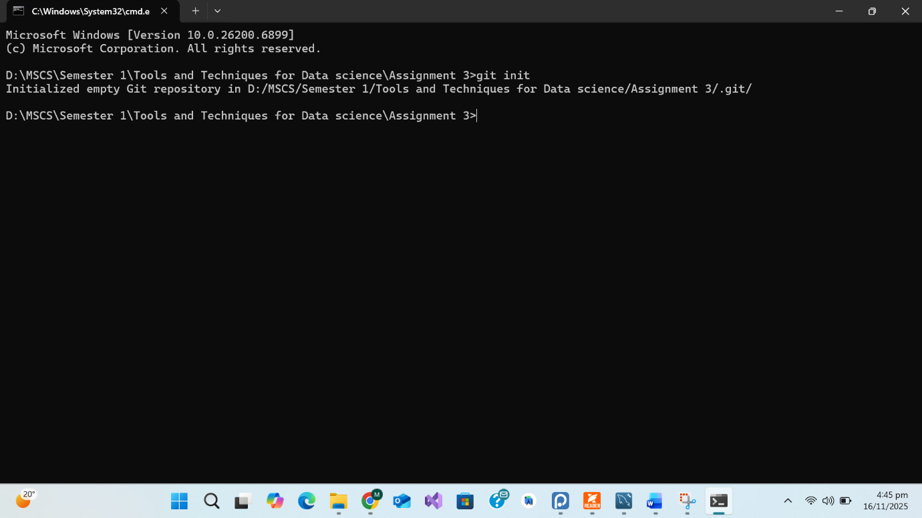

Now I created R file and add it to staging using git add:
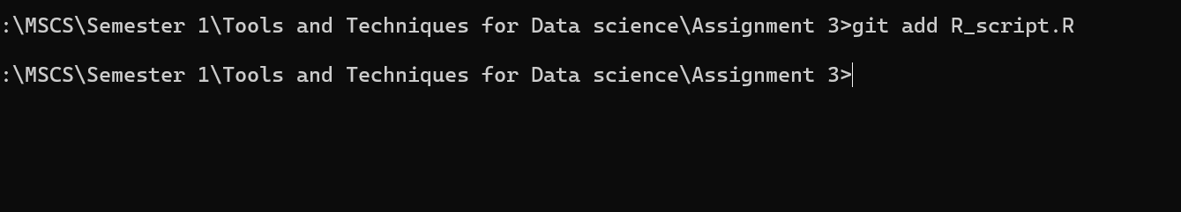
Now I checked status:

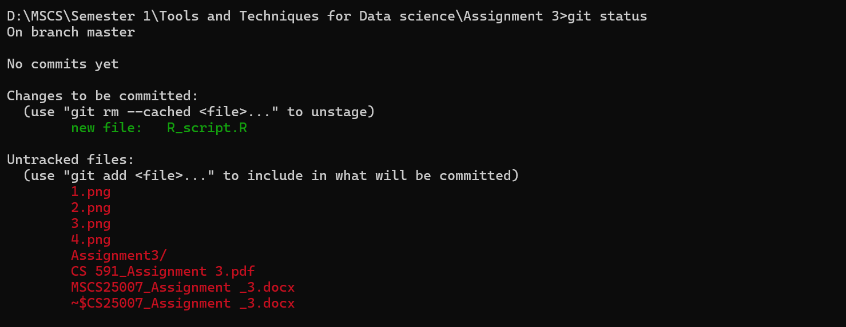

Commit:
Installed package data.table:
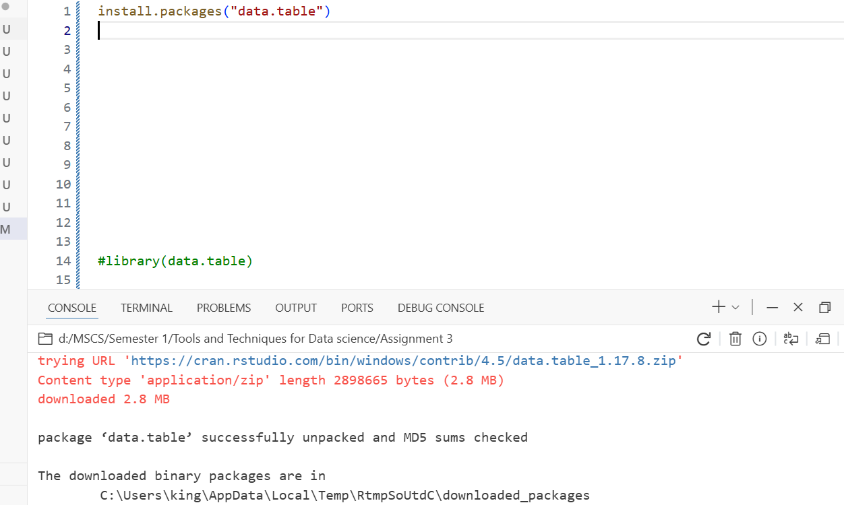
Now added film table in r studio:
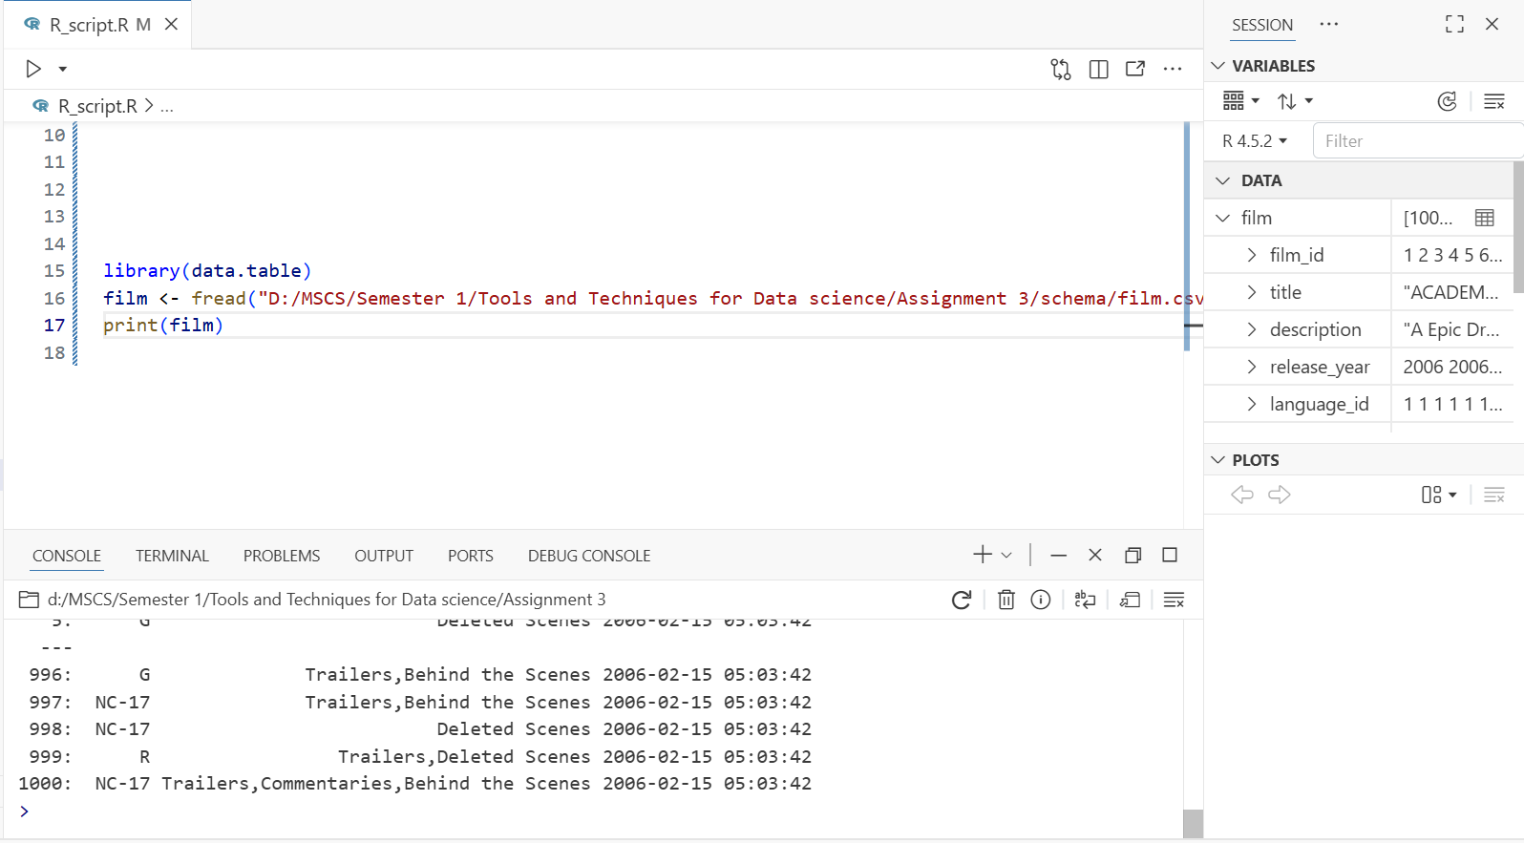
Now i add changes to staging and commit them
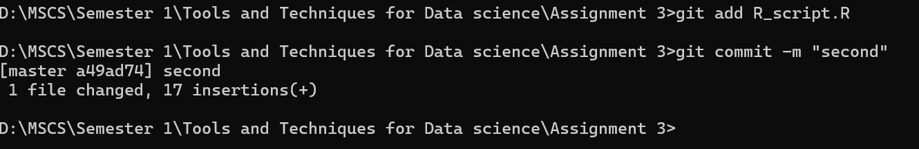
Q#1
- Write a query to display all films that have a rating of PG and a rental duration greater than 5 days.

Q1 <- film[rating == "PG" & rental_duration > 5,
.(film_id, title, rating, rental_duration)]

print(Q1)

i write this query for getting results for task 1

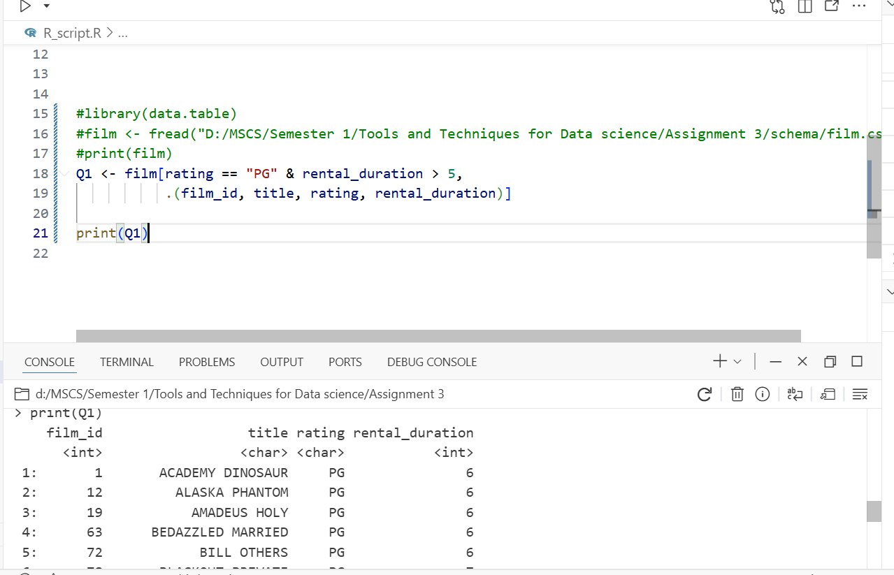
after staging again commit
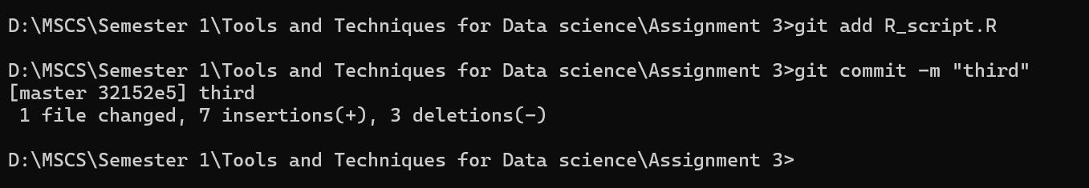
Q#2

- Write a query to display the average rental rate of films, grouped by their rating
Added all the tables:
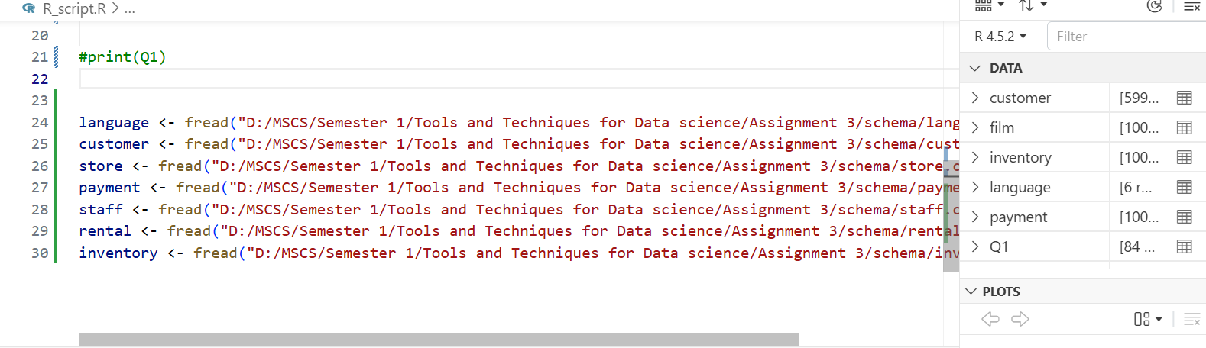
Now i wrote code for getting results of 2nd task : Q2 <- film[, .(avg_rental_rate = mean(rental_rate)), by = rating]
print(Q2)
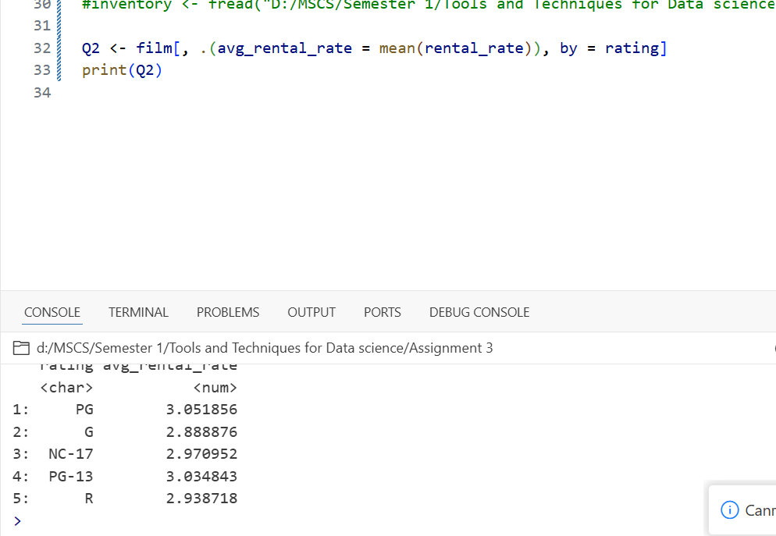
I used the data.table package to group the film dataset by rating and calculated the average rental rate using the mean() function.
The result shows each rating category along with its average rental rate.
Use of git:
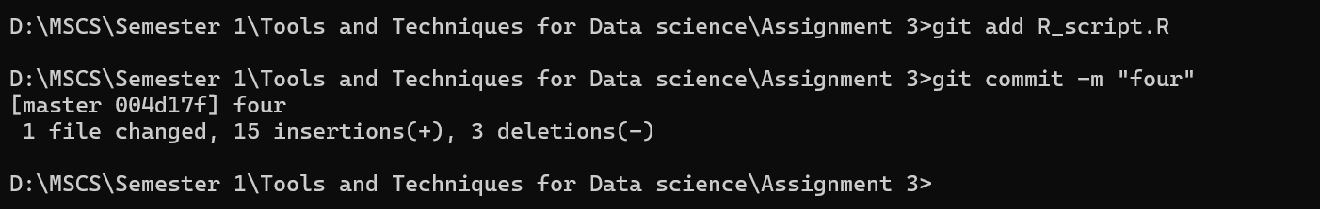
Q#3

- Write a query to count the total number of films in each language.

Q3 <- film[, .(total_films = .N), by = language_id]
print(Q3)

I grouped the film dataset by language_id and used .N to count the total number of films in each group.
The output displays how many films exist for every language.
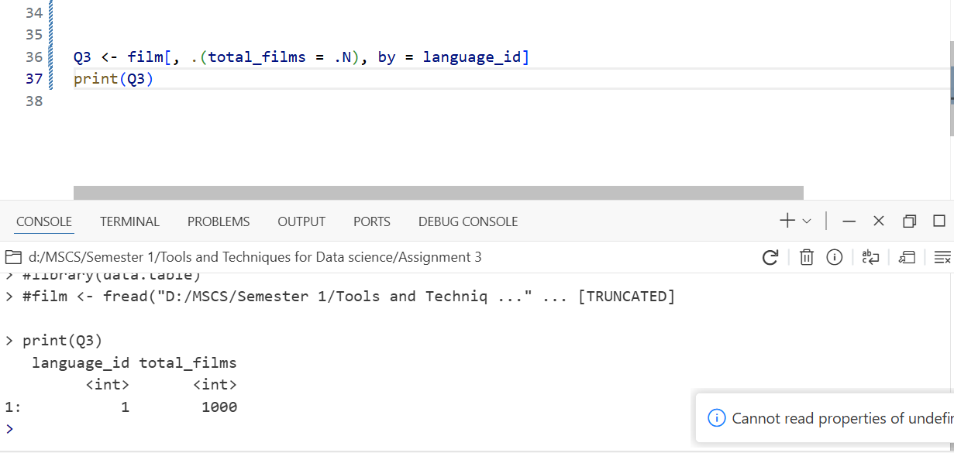
Use of git :
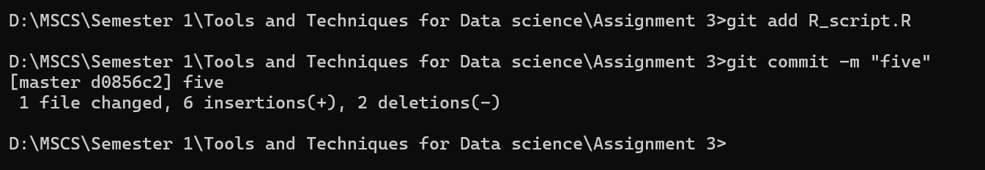
Q#4

List the customers’ names and the store they belong to.
Q4 <- merge(customer, store, by = "store_id")[
, .(first_name, last_name, store_id)]

print(Q4)

I joined the customer and store tables on the store_id column.
After joining, I selected only the columns needed:
- first_name
- last_name
- store_id
This shows each customer along with the store they belong to.
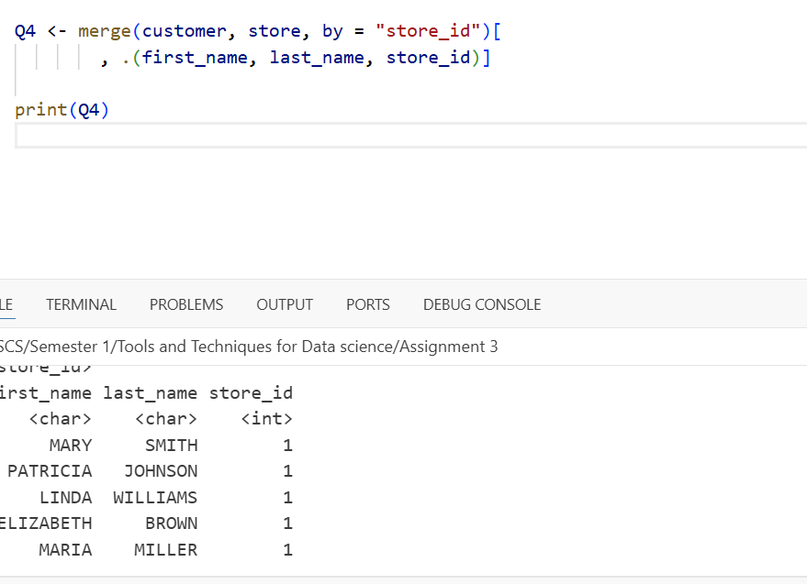
Use of git:
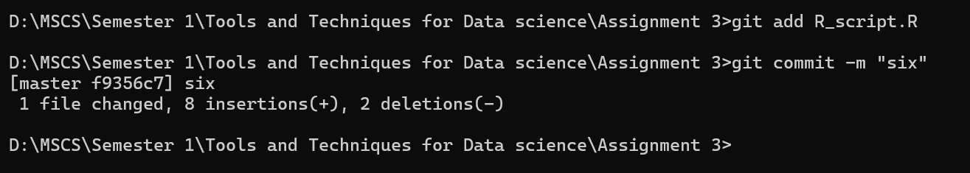

Q#5
Display the payment amount, payment date, and the staff member who processed each payment.
Q5 <- merge(payment, staff, by = "staff_id")[
, .(staff_name = paste(first_name, last_name),
amount,
payment_date)]

print(Q5)

I merged the payment and staff tables using the staff_id field.
Then I created a single staff_name column by combining first and last names.
Finally, I displayed the payment amount, payment date, and staff member for each transaction.
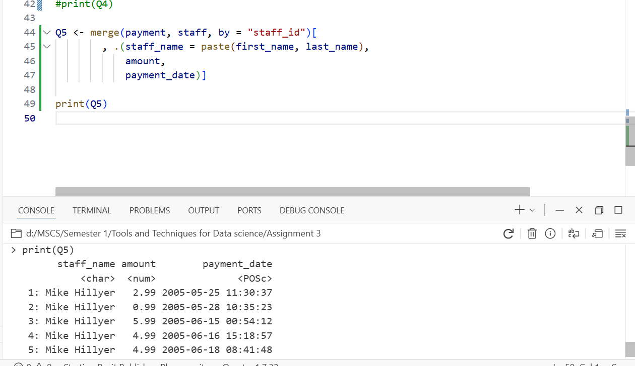
Use of git:
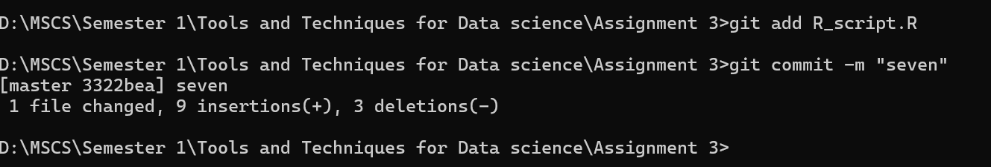
Q#6
Find the films that are not rented.
rented <- merge(rental, inventory, by = "inventory_id")[, unique(film_id)]

Q6 <- film[!(film_id %in% rented), .(film_id, title)]

print(Q6)

To find films that were never rented:
- I joined rental and inventory to get all film_ids that have been rented.
- I selected unique rented film IDs.
- I filtered the film table to keep only films that are not in the rented list.
This returns all films that have never been rented.
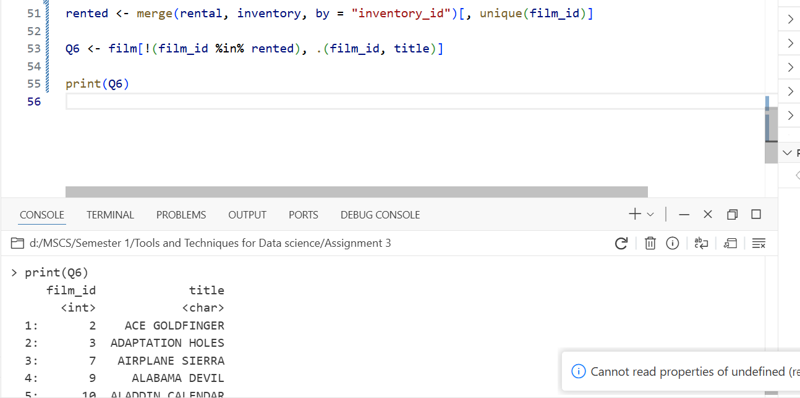
Use of git:
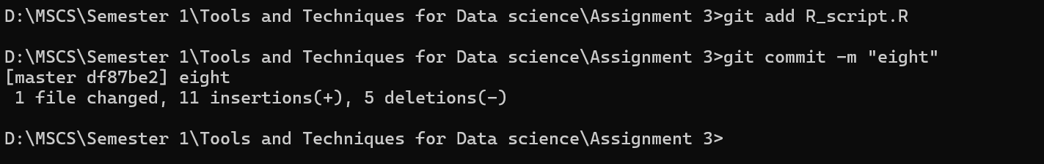

Q#7
Plot any graph of your choice.
library(ggplot2)

rating_counts <- film[, .N, by = rating]

ggplot(rating_counts, aes(x = rating, y = N)) +
geom_bar(stat = "identity") +
ggtitle("Number of Films by Rating") +
xlab("Rating") +
ylab("Count of Films")

I first counted the number of films per rating using data.table.
Then I used ggplot2 to create a bar chart that shows how many films exist in each rating category.
This gives a clear visual representation of film distribution.
Downloaded all packages required:
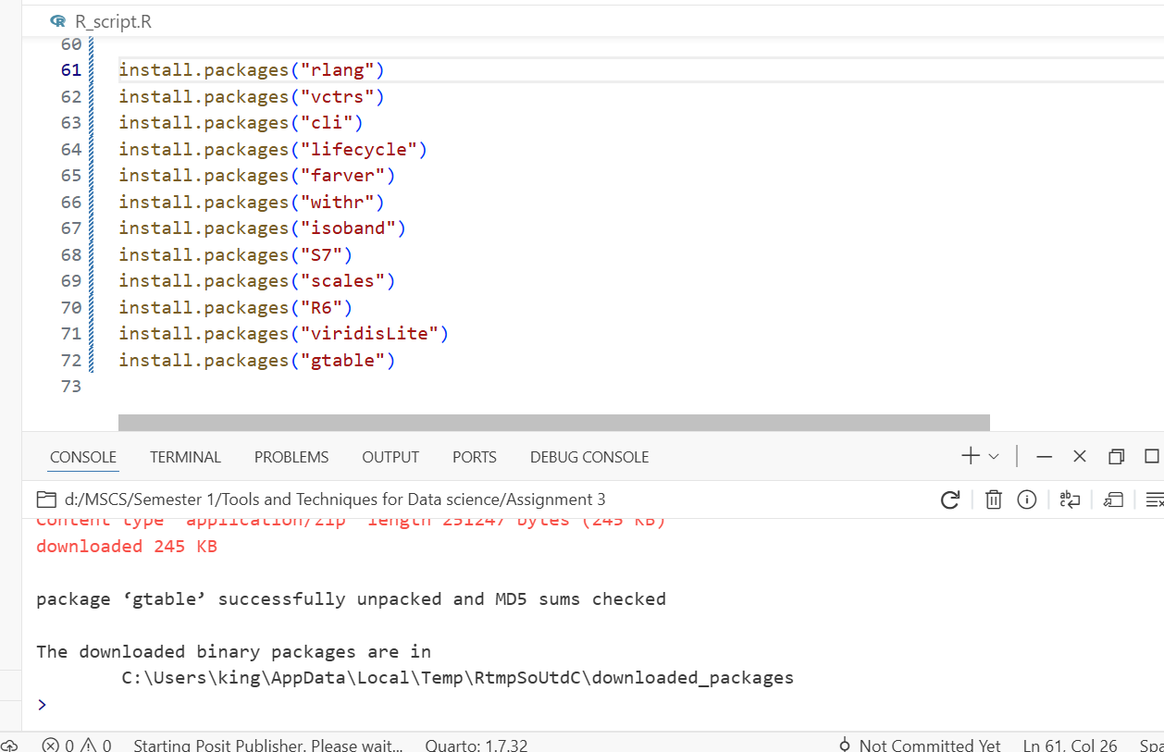
ggplot installation :
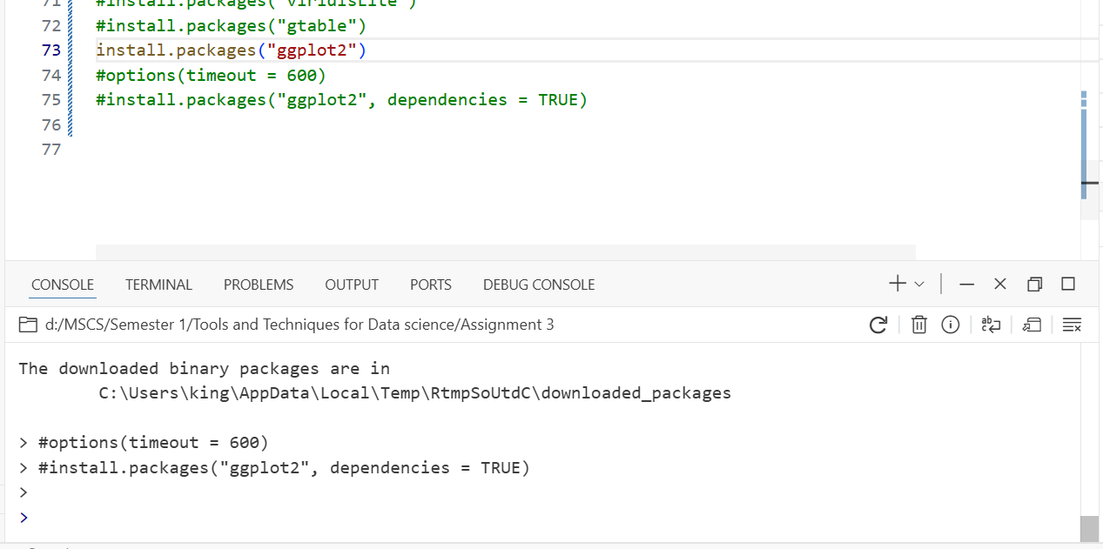
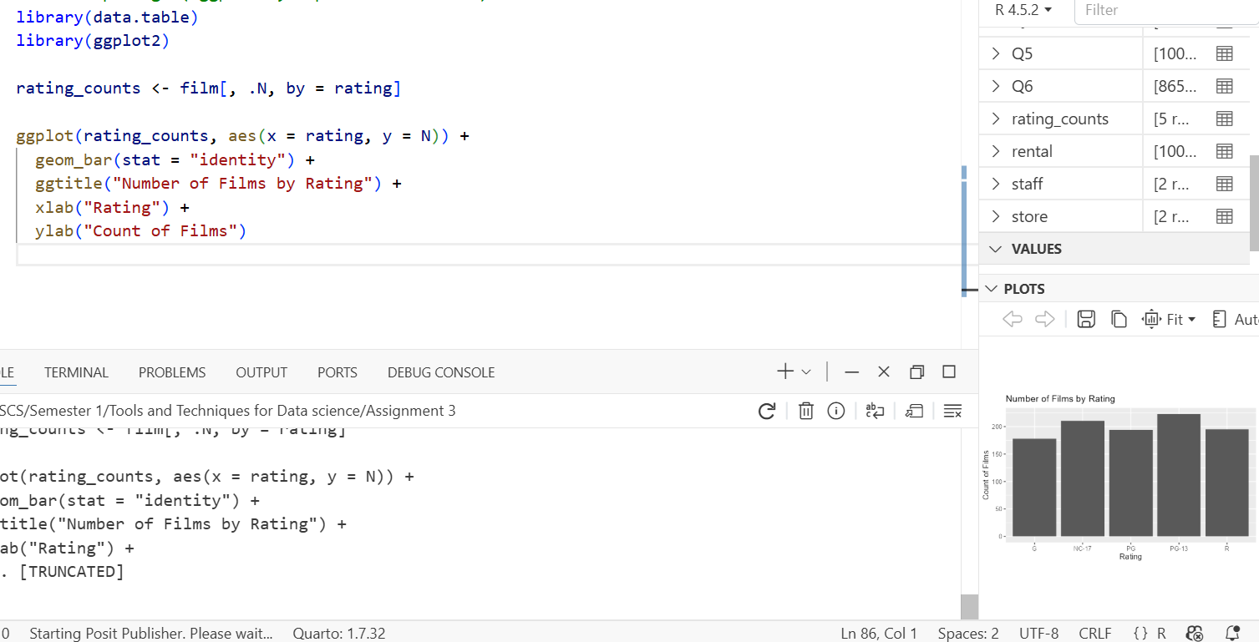
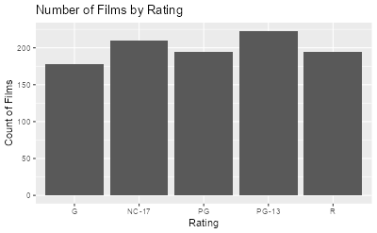
Git use:
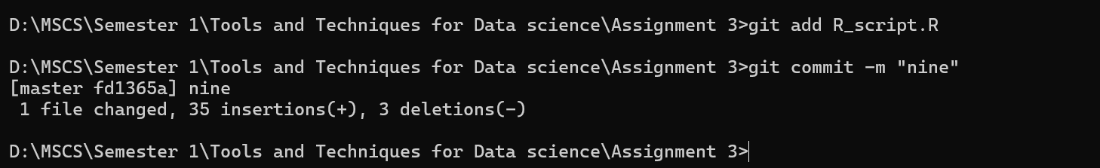
Q#8
Use of Git in the entire assignment.
